Nalongsone Danddank Student ID : 14958950 StarID: jf3893pd
Email: nalongsone.danddank@my.metrostate.edu\
ICS 365. Organization of Programming Languages.
Programming Assignment 2

Points: 40 Goals: More Learning Using C programming.
Problem:
Create a C program that tests whether a sequence of positive integer numbers in the first part of the sequence match the sequence in the second half. Integers must be of value 1 to 99. Nothing less than 1 (accept zero when ending number entering, see below) and must not be larger than 99.

Given a sequence numbers, such as:
7 5 9 13 12 7 5 9 13 12
The first half would be the same as the second half

Given a sequence if number, such as:
1 2 3 4 5 2 3 4
The first half does not match the second half

The user must enter an even number of integers. A sequence like this would not be acceptable
Input: 1 2 3 4 5 1 2 3 4
The number of integers entered is odd.

The program MUST accept a sequence of positive integer numbers (values 1 to 99). The program must then check the sequence for equivalence and print the result. You can assume that the maximum size of the sequence is 100. You NEED to use 0 to mark the end of the sequence. So when a user enters 0 they are done entering numbers, the 0 is a marker only and not considered part of the sequence.

Please remember to organize the code as below:
- Have TWO functions besides main (MUST use proper function declaration)
  - one that accepts the sequence and
  - the other that checks for order equivalence and returns an Y or N depending on the test
- The main function prints the message for the user.
- You cannot use any global variables.

Solution:

#include <stdio.h>
#include <stdlib.h>
// declaration function.
int accept_sequence(int []);
char check_equivalence(int, int []);

int main(int argc, char *argv[]) {
// initilize valiables
int sequence [100];
int i;
int size;
char answer;
// ask user to input the sequence by correctly.
printf("Input sequence number: ");
size = accept_sequence(sequence);
if (size == -1){
printf("You have to put number 0 to the end of Sequence!\n");
return 0;
}
if (size == -2){
printf("Each value must be in range 1 to 99.\n");
return 0;
}
if (size%2 != 0){
printf("The number of integers entered is odd!\n");
printf("You must enter an even number of integers.\n");
return 0;
}
// check sequence is equivalence or not.
// then get the answer and show the result.
answer = check_equivalence(size/2, sequence);
if (answer == 'Y')
printf("The first half is same as the second half!\n");
else
printf("The first half does not match the second half!\n");
return 0;
}
/* for accept the input string from user,
* then convert to integer and put in to sequence array.
* @params sequence - array type: int
* @return size of sequence - int.
*/
int accept_sequence(int sequence[]) {
int j = 0;
char *input[200];
// get one line input string from user.
scanf("%[^\n]s",&input);
// split input string by empty space,
// then convert each string to integer,
// assign to sequence array and end by 0 .
char *p = strtok(input, " ");
while(p){
// convert each string to integer.
int element = atoi(p);
sequence[j] = element;
// if an element is not in range 1 to 99 return -2.
if(element <0 || element >99) return -2;
// stop by number 0 that mean the end
// and return a size of sequence array.
if(element == 0) return j;
p = strtok(NULL, " ");
j++;
}
return -1;
}
/* for check the sequence integer array,
* then return the result it is The first half
* is same as the second half or not.
* @params:
* sequence - array type: int
* size - int
* @return answer of result - char.
*/
char check_equivalence(int half_size, int sequence[]){
int k;
for (k=0; k< half_size; k++)
if(sequence[k] != sequence[k+half_size])
// if a element in the first half is not same
// the last half of sequence array then answer is N.
return 'N';
return 'Y';
}

Screen result:

screen#1: “The first half would be the same as the second half.”
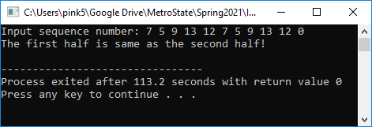

screen#2: “The first half does not match the second half.”
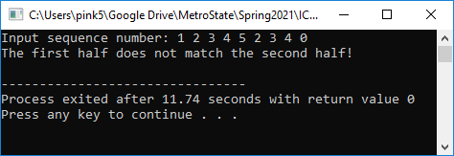

screen#3: “The user must enter an even number of integers.”
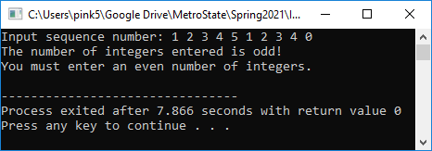

screen#4: “Each value must be in range 1 to 99.”
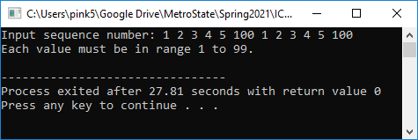

screen#5: “You have to put number 0 to the end of Sequence!”
